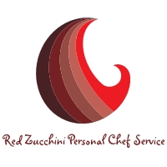

Menu 11/28/15
Butternut Squash Soup w/avocado, lime & basil relish
Spaghetti Squash roasted red pepper sauce and beef & turkey meatballs
Garden Salad
Ranch Dressing
Southwest Sweet Potato Chili
Black Bean & Guacamole Burritos
Spiralized YellowSquash w/Basil and Mint Pesto

